JOY KARMOKAR (18-39263-3)

CLASS LAB TEST

COA (I)

INCLUDE "emu8086.inc"

.MODEL SMALL

.STACK 100H

.CODE

MAIN PROC

PRINT "ENTER ACADEMIC YEAR (1, OR 2, 0R 3):"

MOV AH,1

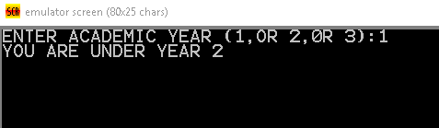 INT 21H

PRINTN

MOV CL, 2

SUB AL, 48

CMP AL, CL

JL FIRST

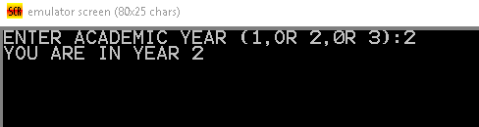 JE SECOND

JG THIRD

FIRST:

PRINTN "YOU ARE UNDER YEAR 2"

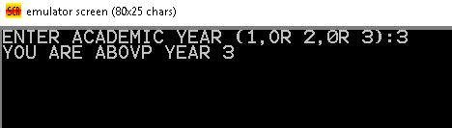 JMP END_CASE

SECOND:

PRINTN "YOU ARE IN YEAR 2"

JMP END_CASE

THIRD:

PRINTN "YOU ARE ABOVP YEAR 3"

END_CASE:

MOV AH, 4Ch

INT 21H

MAIN ENDP

END MAIN